Covid-19 Pandemic Moderating The Influence of Competence, Work Motivation and Entrepreneurship Orientation on Business Performance and Sharia Perspective

Sarwani Sarwani¹, Heru Suprihhadi², Dian Feriswara³, Damajanti Sri Lestari⁴, Liling Listyawati⁵
Universitas Dr. Soetomo Surabaya^{1,3,4,5}, Sekolah Tinggi Ilmu Ekonomi Indonesia (STIESIA) Surabaya²
sarwani@unitomo.ac.id¹, herusuprihhadi@stiesia.ac.id², dianferriswara@unitomo.ac.id³, damajanti.sri@unitomo.ac.id⁴, liling.listyawati@unitomo.ac.id⁵

ABSTRACT
The purpose of the article to analyze and empirically provethat the COVID-19 pandemic moderates the effect of competence, work motivation, and entrepreneurial orientation towards the business performance of SMEs. This study applies an explanatory approach to explain the causal relationship between variables through the hypothesis testing. Research data was collected by utilizing a questionnaire distributed to 130 SMEs and configured in 44 center groups in the city of Surabaya. Data analysis was conducted by Partial Least Square (PLS) approach.” Theresearch finding indicates that the COVID-19 pandemic as a moderating variable of the influence between variables. However, it turns out that not all the relationships regarding the COVID-19 pandemic are significant or strengthening.The empirical findings from the results of this study indicate that the COVID-19 pandemic has had a significant effect on competency, entrepreneurial orientation and business performance, as well as demonstrating the effect of entrepreneurial orientation on business performance.As for the effect of work motivation on entrepreneurial orientation and business performancehas an insignificant effect

Keywords: COVID-19 Pandemic, Competence, Work Motivation, Entrepreneurial Orientation, and Business Performance

- INTRODUCTION
The existence of SMEs plays a significant contribution in various aspects of developments in Indonesia. Several contributions in economic and social development to the state and society include import substitution, growing exports, investment, use of local materials, provision of employment (labor absorption), and distribution of regional development (Clapham 1991). Data from the Ministry of Cooperatives and SMEs in 2017 reported that the number of micro-enterprises in Indonesia was 62,106,900 business units or 98.7% of the total business units in Indonesia, contributing 36.82% of the national gross domestic product and were able to absorb a workforce of 107, 232, 992 people or 89.17% of the total workforce in Indonesia(Kementrian Koperasi dan Usaha Kecil dan Menengah 2018).
The size of the contribution of SMEs to national development, the performance of SMEs is thus pivotal to be considered. Business performance refers to a result achieved from the ability for develop new idea and to navigate new way of observing the problem and opportunity as well as ability of applying creative solutions to problems and opportunities in order to improve people's lives”(Smith and Chimucheka 2014). In addition, business performance is influenced by several factors such as the internal and external environment. The internal environment includes resources, entrepreneurial orientation, and mastery. Meanwhile, the external factors consist of government policies, market competition conditions, social conditions and environmental and global economic changes (Darsono 2015; Munizu 2010).
Human resources serve as an important critical point in business performance, as the owner of the SME also typically functions as the manager, who operates the business and organizes people. Thus, managerial competencies such as planning and organizational skills, administrative management, and communication skills are required to improve performance. Additionally, entrepreneurial competence is required by a business when facing competition, both domestically and internationally (Ng and Kee 2013). Research shows that competence has a significant influence on performance, increases competitive advantage and as a medium for surviving in a business environment in uncertain situations and conditions.(Lotunani et al. 2014).
To achieve optimal performance in business, entrepreneurs are encouraged to work along with high motivation to achieve a special level of competitiveness within strong competition. Motivation has been perceived as a change in all people’s energy characterized by the emergence of feelings, initiated by a response to the existence of a goal. Entrepreneurial motivation from business creation hence could influence decisions regarding business performance (Greenberger and Sexton 1988). If entrepreneurs are motivated, they will make positive choices to do something.
In the meta-analysis study conducted by Stewart and Roth (2007), the two scholars highlighted several differences between entrepreneur motivation and manager motivation. Therefore, entrepreneurial motivation should be underlined particularly on the personal characteristics of entrepreneurs. Understanding entrepreneurial motivation deals with analyzing the individual and entrepreneurial processes behind the creation of new ventures (Naffziger, Hornsby, and Kuratko 1994).
The internal factor affecting the performance of SMEs includes the entrepreneurial orientation (Darsono 2015), asa factor that contributes to business performance improvement. The entrepreneurial orientation of SMEs will determine the goals or focus of the competitive advantage, in which greater entrepreneurial orientation of the company generates the company’s ability to make changes and to react quickly towards these changes.
Businesses with a strong entrepreneurial orientation will be more courageous to face risks by not holding onto past strategies. In a dynamic environment, entrepreneurial orientation is deemed pivotal for the survival of the company (Lumpkin & Dess 1996). Entrepreneurial orientation refers to a trait and characteristic, actualizing innovative ideas into the reality, creatively accomplished; thereby resulting in the new and different outcomes. Entrepreneurship orientation as a process along with an action-oriented management style, implements innovation and change as the focus of thought and behavior (Day, Reynolds, and Lancaster 2006).
Research indicates that performance is significantly influenced by entrepreneurial orientation. Prior studies (Isa 2012; Purwanto and Trihudiyatmanto 2018; Suprihhadi 2013; Zainol and Ayadurai 2010), confirmed that entrepreneurial orientation however had insignificant effect on the implications of business performance (Wang and Li-Hua 2010).
Accordingtothe Resourcel-lBased Viewl theory, “resources become the inputs for the production process of a company that are considered valuable, rare, non-replicable and non-substitutable resources, and are potential to achieve competitive advantage and superior performance” (Barney 1991). “This approach is implemented to study companies based on the two basic assumptions, including: first, resource diversity” (Penrose 1959) which assumes that “each company has a different set of productive resource ties; and second, untransferable resources, which assumes that some of these resources are significantly expensive to duplicate or that the supply is inelastic” (Barney 2001).
In essence, the RBV perspective emphasizes the importance of unique and different resources as a source of competitive advantage (Dollinger 2008; Rumelt 1984).
One of the external factors that affect the performance and growth of SMEs emerging since 2019 has been the COVID-19 pandemic, depicting a direct impact on companies, both for large and small businesses(Ruiz Estrada, Koutronas, and Lee 2020; Sansa 2020). SMEs, which have been at the forefront of the economic pillars in Indonesia, were able to survive the shocks of the economic crisis in the previous 1999s, are expected to be able to survive the COVID-19 pandemic crisis.
The implementation impact of Large-Scale Restrictions (PSBB) has suddenly immobilized the state economic activity, which was evident from the declining demand; thereby disrupting the supply chains across Indonesia. In the initial survey, more than 50% of SMEs in Indonesia indicated that they could go out of business in the next few months after the pandemic in early March 2020, which would certainly demonstrate a huge impact on the Indonesian economy (Zulkifli 2020).
Several studies report that the pandemic brings the difficulties for Small and Medium Enterprises (SMEs) associated with low-income gains affecting the business operations and sustainability. SMEs experience in terms of shortage of financial resources becomes the biggest challenges for short-term and long-term recovery in the COVID-19 situation (Cumbie 2007). However, the business cycle is required to keep running and exist due to their significant role in supporting the economy. In currently difficult conditions, it is thus necessary to foster entrepreneurial motivation for SMEs to continuously achieve maximum results based on all the competencies possessed by business actors. In addition, SMEs are also required to think outside the box in effort to produce innovations and improve their business.
Referring to several previous research and existing theories, this paper aims to empirically analyze, test, and discuss the causal relationship indicatedemonstrating “the influence of competence and work motivation on entrepreneurial orientation and business performance moderated by the COVID-19 pandemic on micro-enterprises at the Tourism Center, Culinary Surabaya City.”
Islamic Entrepreneurship Development is currently a breakthrough or such an important step by looking at the current conditions that there are still many business actors who ignore moral values ​​in Entrepreneurship just pursuing worldly gains that are only temporary and ignore the benefits ukhrawinya. One of the fundamental goals of this phenomenon is used as a research study because as the development of entrepreneurship theory from relevant Muslim scholars with current economic phenomena. It is also used as a theoretical study explains a theory that applies to a phenomenon.Thereforewe will also see how the forms of entrepreneurship in the perspective of Islamic economics.

- THEORITICAL
Business Performance
Business performanceis al result made by management on an ongoing basis, which particularly is the result of the decisions of many individuals based on the levell ofllachievementllor profession lof thellcompany lin lallcertain lperiod (Helfert 1996). Thel success ofl business performance is inseparable from the role of an entrepreneur in conducting his business activities (Lestari 2009). To become a successful entrepreneur, a strong attitude and behavior as well as a strong sense of independence are thus essential (As’ad 2012).
The assessment and measurement of business performance is not only applied asall measure of the organization success within a certain period but also implemented as input for further improvement of organizational performance. Business performance is measured by instruments, including: (1) Qualitative and quantitative, (2) Financial and non-financial, depending on the need for measurement. Financial measures, generally financial ratios, consist of: Liquidity Ratio, Leverage, Activity, Profitability, and Market Value (Sloma 1980). Meanwhile, the supporting factors for business growth include personality, management skills, goals, and so forth. The entrepreneur's ability to handle the business growth is critical when aiming for the company’s survival amidst the accompanying chaotic atmosphere (Lambing and Kuehl 2003).

Competence
Competence refers to the ability possessed by an individual and the selling value along with the application of creativity and innovation. In essence, competence refers to an individual characteristic (Fahmi 2014), serving as basic characteristic of people leading to how to behave, think, adapt to situations, and survive for along periodoftime. Competency characteristics are indicated as follows: (a) Motive; (b) Nature; (c) Self-concept; and (e) skills (Spencer and Spencer 2011). Thus, competence is a behavioral dimension that is behind the competent performance (Michael and Baron 2010).
Entrepreneurial competence refers to the ability that a person has in the creation of entrepreneurial activities (Saiman; 2009). The abilities that support entrepreneurship involve creative and innovative abilitiesin crafting the new and different, start up, opportunity, risk bearing, idea development and resource combination (Soegoto 2009). Entrepreneurial competence comprisesllknowledge,llattitudeslandlskillslconnectedlto each other, further requiring the train and development tolproducelthelbestlperformancelinlmanaging business.

Motivation
Motivation comprises a person's desire to act (Heller 2011), asaprocess generating a person's intensity, direction, and continuous effort towards achieving goals (Robbins 2003). “Motivation involves a series of processes that generate, direct, and maintain human behavior towards the achievement of goals”. Therefore, the notion of work motivation becomes an encouragement from within a person and or from external factors indicated by a series of processes of one's behavior to achieve organizational goals (Greenberg and Baron 2010). Furthermore, the elements contained in work motivation include the following actions such as to: generate, direct, maintain, indicate intensity or intention, continue, and achieve a goal (Wibowo 2007).

Entrepreneurship Orientation
Entrepreneurshiplorientation involves the ability of someone engaged in a business having a mindset with basic characters, suchas action-oriented, modest thinking, creating opportunities with high discipline, thusimplicitly called as an entrepreneur when having an entrepreneurial orientation (Kasali 2010). Entrepreneurship orientation is performed by someone who has the ability to creatively think and innovatively act in order to create opportunities in the engaged business (Suryana 2010). The main capital of entrepreneurship does not solely lie in the money-matters, but the belief to win. Often many people are constrainedby material limitations (such as money, place of business, and products) to start a business, frequently focusing on boundaries and ending up from not moving forward. However, there is capital that is not money, which powerfully affects the success of a business such as, which is the belief to win in business (Kasali 2010).
Entrepreneurshiplrefersltolthelprocesslof creating newland valuable matter through the devoted effort and time involving inner strength, financial capital, social risk along with receiving rewardsintheformof value for moneyand personal satisfaction. Besides having an independent nature entrepreneurship refers to a method to stimulate an individual in capitalizing or taking advantage of opportunities in the organization, by employing creativity (Hisrich, Peters, and Sepherd 2017).

Resource-Based View Theory (RBV)
RBV theorylexplains thelimportancelof resources to provide more economic advantages to owners with fixed or limited resource ownership. The strength of the RBV theory lies in its ability to explain the exploitation of business processes, such as why a company has high performance and competitive advantage compared to its competitors due to the company uniqueness, uncommonness, and irreplacable nature by other resources.
RBV theory considers that “the company is a bond of various resources having a significant effect on the company's competitive advantage and performance. Companies that have unique resources that cannot be imitated by other companies will assist the company survival within the competition. RBV emphasizes the competitive advantage strategy and the company's internal resources” (Barney 1991).
Grant (1991) “classifies resources into the six major groups, such as: financial resources, physical resources, human resources, technological resources, reputation, and organizational resources”. lFurthermore, lGrant (1999) stateslthat “the five main dimensions of resource-based strategy include financial sources to identify the ability of businesses in calculating the funds and income, as well as the risk of internal loss determined based on the entire product manufacturing process”.“Physical resources sustain the results of business products’ efficiency and accuracy in determining the expected costs and revenues as an indication of selling prices to consumers. Meanwhile, human resources are functioned to achieve the production effectiveness, by giving employees responsibility for calculating the product costs and revenues during production. Technological resources are aimed at achieving the effectiveness of manufacturing process and product development to achieve better quality based on the capabilities. Lastly, the organization's reputation resources provide good customer relations for the acceptable product result and supplier confidence in sustainable purchases.”

Relationship of Competence, Work Motivation to Entrepreneurship Orientation
Zwell (2000) stated that the competency model was differentiated based on position, level and work function; while level and work function are further differentiated based on superior or not superior nature, as well as between partners and superiors. Competence according to level and work function is employed to distinguish both superior and non-superior nature which includes competence regarding the ability to influence, to develop other people who are motivated, to work together, to build focus and to endeavor concern for quality, result orientation, according to the needs in the related field. The mindset of an entrepreneur unavoidably includes the problem of consumption; thus, an entrepreneur is encouraged to be productive and not consumptive
An entrepreneur according to Kasali (2010) is constantly challenged with risks, uncertainties, and limitations in each arising problem. When action does not speak louder, it is not impossible that such attitude will lead to a disaster or loss amidst the constantly changing opportunity. The orientation of an entrepreneur is often acknowledged as to plan, do, check, and act. This orientation means that an entrepreneur not only makes plans with various strategies and tactics, but also implements them until obtaining the supervised and controlled results.
Furthermore, Kasali (2010) pointed out that the strong motivation of an entrepreneur has been inadequate to solely rely on creative ideas in making products as innovations without an accurate strategy and proper execution. This notion means that an entrepreneur cannot work alone instead, requiring supporting ideas initiated from the emergence of ideas to convey the commercialization stage. In addition, success is determined by numerous things, one of which is through understanding the character andthe actual position, thus it is not impossible that success is only a matter of time for entrepreneurs who really love their work. Most successful entrepreneurs state that the product, no matter how simple it is, “it must be familiar with”, engaging with a personal touch of affection. Hence, prior to find a real product or business idea, knowing oneself and strengthening one entrepreneurial orientation are deemed essential either in motivating ourselves or employees or subordinates.

Relationship of Competence, Work Motivation to Business Performance
Competence relates to the ability to master skills/expertise in a particular field, accommodating a person to work appropriately, quickly, regularly, and responsibly. Accordinglto Robbinsl&lJudge (2008), “ability refers to an individual's capacity to perform various tasks in a tasked job”. Basically, abilitieslare divided into 2 major groups, including intellectualabilities and physicalabilities. According to Mangkunegara (2008), psychologically, “ability consists of potential ability (IQ) and reality ability (knowledge + skill), in which the business actors who have an average IQ (IQ 110 - 120) with adequate education and are skillful in accomplishing their work, it willbe easierfor them tolachievelthelexpectedlperformance.
“A person's motivation starts from the needs, desires, and urges to act to achieve the needs or goals, indicating the strong drive, effort, intensity, and willingness to sacrifice for the achievement of goals. In this case, stronger drive or motivation and enthusiasm lead to higher performance.” Thislperspective islinlaccordancelwithlthelopinion of Mathis and Jackson (2007) asserting that motivation becomes a desire in a person directing a person to act. Motivation thus serves as a drive driven by goals and rarely appears in emptiness.
Overall, greater motivation would generate stronger efforts to achieve the goals, involving further attempt to take advantage of the various abilities. As a result, if a business actor has high ability with high motivation, he would utilize all his abilities to actualize his ambitions.

Relationship of Entrepreneurial Orientation to Business Performance
Porter (1990) “defines entrepreneurial orientation as a company's benefit strategy to compete more effectively within similar marketplace. The entrepreneurial orientation, reflected in an attitude full of innovation, proactiveness and courage to take risks, is believed to boost the company's performance”. Wiklund (1999), previously stated that higher entrepreneurial orientation might lead to the increasing company'slabilityltolmarketlitslproductsltowardslbetterlbusinesslperformance. A high entrepreneuriallorientationlis closely relatedltolthe main driversof profit in which an entrepreneur could take advantage and response to opportunities, which in turn hasapositive effecton business performance. Covin & Slevin (2017) added thatlthelentrepreneurial orientation of an entrepreneur generates in the increasing outcome in business performance.
SMEs that seek to improve their company performance are advised to focus on the two things, such as entrepreneurial orientation and business strategy. Entrepreneurial orientation relates to alcreativelandlinnovativelabilitylusedlaslthelbasis,ltips,landlresourcesltolfindlopportunitieslfor success.

Relationship of Competence, Work Motivation, and Entrepreneurship Orientation to Business Performance moderated by the Covid-19 Pandemic
ThelCOVID-19lpandemic becomes a trigger demonstrating the situation and conditions due to corona virus, widely health and safety, and in all fields, including the economy and business. The impact, especially related to the sustainability of the business world such as SMEs, is thus inarguably enormous. Therefore, in the era of a new normal, new behavior and new habits in running a business in each SME is encouraged to be performed. As an impact in business, each SME in Surabaya has navigated its new ways, inherently by complying with the COVID-19 health protocol and applicable laws and regulations, involving the competence and work motivation as well as entrepreneurial orientation to business performance during the redevelopment process.

Competence
Covid-19 Pandemic

Business performance
Entrepreneurship Orientation

Work Motivation

Figure 1. Research Model

- METHODOLOGY
This research utilizes an explanatory and causal, by explaining the causal relationship. The target population includes micro-entrepreneurs in the Culinary Tourism Center and registered at the Department of Cooperatives and Micro Enterprises, as amounting to 959 SMEs. The research sample was 130 SMEs, determined by using the proportional cluster random sampling technique with the criteria of having a minimum education of Junior High School or its equivalent, business duration of more than 1 year and own capital used was higher than IDR. 5 millions. The datawas collectedbyusing a questionnaire and measured on a Likert scale to obtain agreement or disagreement with a score of 1 to 4. Meanwhile, the unit of analysis applied the Structural Equation Modeling (SEM) operated through AMOS program. SEM is a multivariate statistical technique which is a combination between factor analysis and regression analysis (correlation), which aims to test relationships - relationships between variables that exist in a model, both between indicators with the construct, or the relationship between constructs (Santoso, 2007).

- RESULT AND DISCUSSION
RESULT
Respondent Profile
Respondents were mostly women comprising by 56.9%, aged 41-50 years by 36.9%, high school education by 43.1%, operating more than 3 years by 77.7%, selling food and beverages as much as 51.5%, issuing own capital more than IDR 25 million or 46.2%, and the frequency of daily transactions with more than 60 people or 53.8%.

Structural Equation Modeling (SEM)
“The structural model is initiated with an evaluation of the structural goodness of fit which aims to ensure that the developed model is in accordance with the data (fit). The results of the estimation of the structural model and the value of the goodness of fit criteria are presented in” the following Fig.2
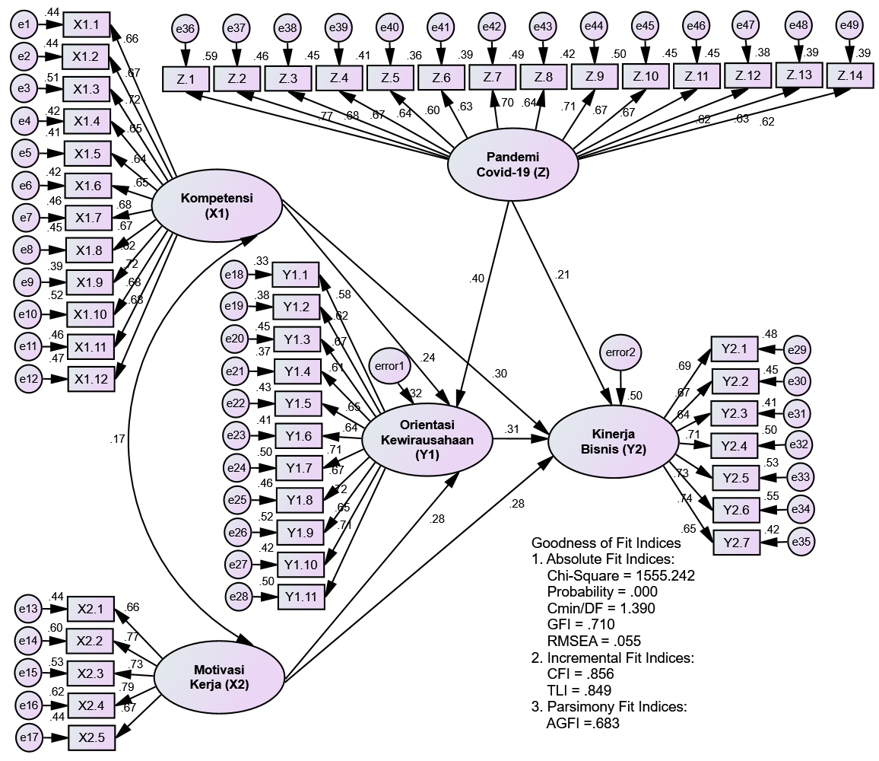

Competence
(X1)
Work Motivation(X2)
Entrepreneurship Orientation (Y1)
Covid-19 Pandemic (Z)
Business
Performance (Y2)

Figure 2. Full SEM Model Results (Base Model)
The calculation results of the goodness of fit index value generated by the structural model of the SEM base model arelpresentedlinlTablel1 as follows:
The results of the structural model suitability test (base model) indicate that there are several criteria show poor results (poor fit), thus the structural model can be modified to obtain a better level of model suitability.
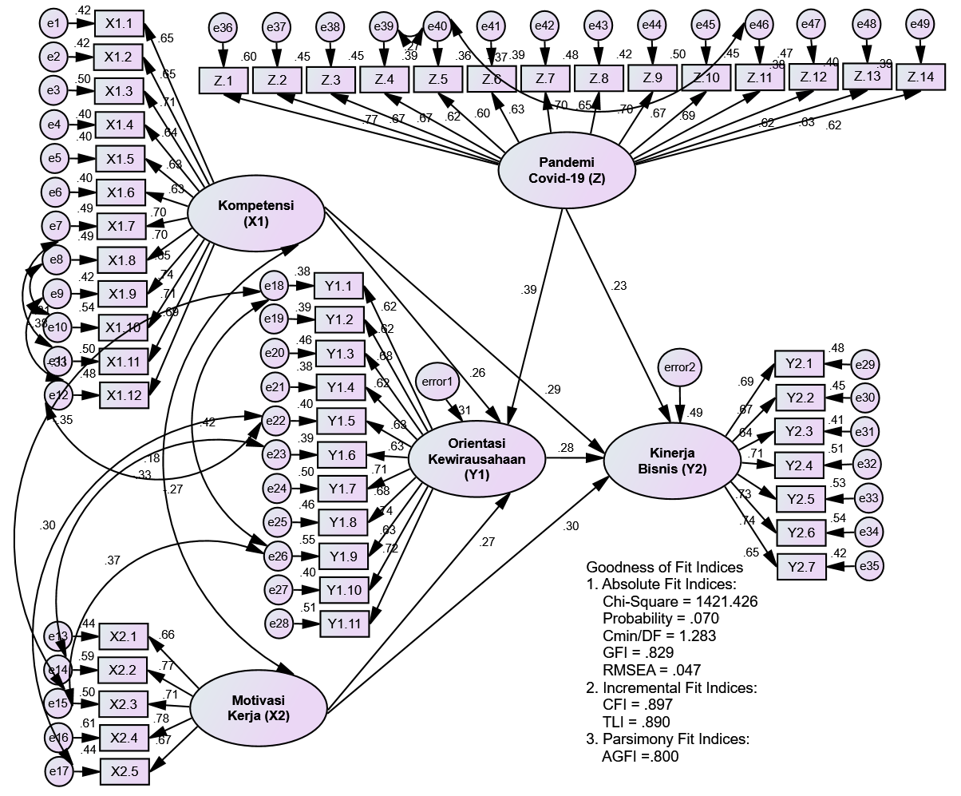

Figure 3. Full SEM Model Results (Modification Model)

The calculation results of the goodness of fit generated by the structural modification model of the SEM are illustrated in Table 2 as follows:

The results of the structural model suitability test after modification indicate that all the model suitability criteria have met the requirements (marginal fit or good fit), further affirming that the SEM model estimation is good and acceptable.

Hypothesis Testing
Table 3. Testing Structural Relationships Between Variables
Hyp | Structural Relationships |  |  | Estimate | C.R. | P  value | Description
H₁ | Competence (X₁) |  | Entrepreneurship Orientation (Y₁) | 0.256 | 2.675 | 0.007
H₂ | Work motivation (X₂) |  | Entrepreneurship Orientation (Y₁) | 0.268 | 2.755 | 0.006
H₃ | Competence (X₁) |  | Business Performance (Y₂) | 0.290 | 3.164 | 0.002
H₄ | Work motivation (X₂) |  | Business Performance (Y₂) | 0.295 | 3.025 | 0.002
H₅ | Entrepreneurship Orientation (Y₁) |  | Business Performance (Y₂) | 0.282 | 2.706 | 0.007

Hypothesis analysis results:
- The results of testing the coefficient of the influence of competence on Entrepreneurship Orientation indicate a significant effect, confirming that the first hypothesiswhich statesthat competence has a significanteffecton entrepreneurial orientation (H1 is accepted).
- The results of testing the coefficient of the effect of work motivation on Entrepreneurship Orientation indicate a significant effect, denoting that the second hypothesis which states work motivation has a significant effect on entrepreneurial orientation (H2 is accepted).
- The results of testing the coefficientof the influence of competence on business performance indicate a significant effect, signifying that the third hypothesis which states that competence has a significant effect on business performance (H3 is accepted).
- The results of testing the coefficient of the effect ofworkmotivationon business performancealso indicate a significant effect, confirming that the fourth hypothesis which states workmotivation has a significanteffect on business performance (H4 isaccepted).
- Theresults oftesting the coefficient of the influence of EntrepreneurshipOrientationon business performance also indicate a significant effect, meaning that the fifth hypothesis which states that Entrepreneurship Orientationhas a significant effect on business performance (H5 is accepted).

Table 4. Testing the Effect of Moderator Variables
Hyp. | Structural Relationships |  |  | Estimate | C.R. | P  value | Description
H₆ | X1*Z |  | Y1 | 0.229 | 3.407 | 0.001 | Significant
H₇ | X2*Z |  | Y1 | 0.029 | 0.227 | 0.821 | not significant
H₈ | X1*Z |  | Y2 | 0.255 | 2.071 | 0.039 | Significant
H₉ | X2*Z |  | Y2 | 0.164 | 1.236 | 0.217 | not significant
H₁₀ | Y1*Z |  | Y2 | 0.499 | 2.692 | 0.007 | Significant
Keterangan:
X1 : Competence ; X2 : work motivation; Y1 : Entrepreneurship Orientation
Y2 : business performance; Z : Pandemi Covid-19 Pandemic

- The effect of the interaction variable X1*Z on Y1 produces a p value <0.05, with a significant moderating effect, thus H6a is accepted.This result means that the influence of competence on Entrepreneurship Orientation will be even stronger with the moderation of the COVID-19 pandemic.
- The effect of the interaction variable X2*Z on Y1 resulted in a p value > 0.05 with insignificant moderating effect, thus H6b is rejected. This result means thatlthelCOVID-19 pandemicldoes not moderateltheleffectlof work motivation onlEntrepreneurship Orientation.
- The effect of the interaction variable X1*Z on Y2 resulted in a p value <0.05 with a significant moderating effect, thus H6c is accepted. This result means that the influence of competence on business performance will increase with the moderation of the Covid-19 pandemic.
- The effect of the interaction variable X2*Z on Y2 resulted in a p value > 0.05 with insignificant moderating effect, thus H6d is rejected. This result means that the COVID-19 pandemic doeslnotlmoderateltheleffectloflwork motivation onlbusinesslperformance
- Theeffect of the Y1*Z interaction variable on Y2 resulted in a p value <0.05 with a significant moderating effect, thus H6e is accepted.This result means that the influence of Entrepreneurship Orientation on business performance will be even stronger with the moderation of the COVID-19 pandemic

DISCUSSION
The results of the research model that was compiled with a modified structural equation approach indicated the suitability of the structural equation model upon modification, where all the criteria for model
Suitability had met the requirements of marginal fit or good fit. Thus far, the estimation of this structural equation model is stated to be good and feasible and acceptable, signifying thatltherelislalcause and effectlrelationshiplbetween the four variables of competence, work motivation, Entrepreneurship Orientation, and business performance which are interconnected as well as one COVID-19 pandemic variable as a moderating variable between related variables.
    - The Influence of Competence on Entrepreneurship Orientation.
The proven influence of significant competence on Entrepreneurship Orientation indicates that SMEs demonstrate the potential selling points and can apply creativity and innovation, generating a positive attitude towards the products to be offered to consumers. This indication is marked by the motives and characteristics of SMEs, self-concept and inherent skills when operating the business. The resultsloflthislstudylare hence consistent with thelRBV theorylthat thelapplication oflthelResourcelBasedlViewlstrategy (Barney 1991; Grant 1991) which emphasizes that optimizing resources and capabilities tolrealizelinnovativelideaslinto the reallbusiness worldlwould createlthe product that is new and different. Small businesses and micro businesses will survive in the competition because of changes in the business environment, only if they have the resources and capabilities (RBV) to create a difference presenting unique characteristics compared to their competitors.

The Influence of Work Motivation on Entrepreneurship Orientation
Theproven influenceloflworklmotivation significantly onlEntrepreneurship Orientation indicates that the work motivation raised by SMEs is significantly enthusiastic to generate, direct, maintain attitude and behavior in running a business to serve the customers. As an indication that SME actors inspire themselves, they tend to direct the goals and achievements of the business they run, by sustaining the viability of their businessand the intensity or intention to do business in a workable manner.
The resultsloflthislstudylare consistent and inllinelwithlthelresource-basedlview that contributes to most researchlonldiversification strategies (Ramanujam & Varadarajan 1989) in the 4lareas. “First, the resource-based approach regards the limitations of diversification growth (through internal development, mergers, and acquisitions). Second, the resource-based approach considers important motivations for diversification. Third, the resource-based approach provides a theoretical perspective for estimating the direction of diversification. Fourth, the resource-based approach provides a theoretical rationale for estimating the high performance of certain categories related to diversification.”
Entrepreneurs, who are action-oriented and highly motivated, are willing to accept risks in achieving their goals. To become a successful entrepreneur, patterns of attitude, behavior, and views are deemed essential to produce bright ideas and realize them into real business. “Based on the resource-based approach, the source of sustainable competitive advantage for companies includes resources that are valuable, rare, uncopiable, and irreplaceable. However, the results of this study are not in line with the”resultslof an empirical study conductedlby Purwanto and Trihudiyatmanto (2018) thatin fact, entrepreneurial orientation has a significant effect towards work motivation.

The Influence of Entrepreneurship Orientation on Business Performance.
The proven influence of Entrepreneurship Orientation is significant on business performance as a research hypothesis of micro business actors, marking that the Entrepreneurship Orientation owned by SMEs is indicated by a strong self-confidence, initiative driven by an energetic spirit in running business, a high achievement motive, a leadership spirit, and risk-taking attitude. SMEs have an entrepreneurial orientation, proved by the confidence and initiative with enthusiasm to have a strong will to do business, high aspirations to advance and develop business, and courage to be different with the spirit in facing challenges amidst the tight competition.
The resultsloflthislstudylarelinllinelwithlthe RBV theory thatlresource-basedlbusiness management provides an alternative solution for SMEs, as such management is potential to create special competencies and to provide strategic choices to achieve excellence (Barney 2001; Grant 2001). Achieving sustainable competitive advantage is inseparable from the resource-based view (RBV) which directs company managementltolidentify, lcontrol, landldeveloplstrategiclresourceslin orderltolproduceloptimallperformance (Barney 2001).
In addition, thelresultsloflthislstudylarelin accordance withlthelresultslof empirical studies conductedlby M. Isa (2012), Zainol and Selvamar (2010), and Suprihhadi (2013) denoting that Entrepreneurship Orientationlhaslalsignificantleffectlonlbusinesslperformance, butlis notlin line withlthe results an empirical study conducted by Wang and Li-Hua (2010) arguing that Entrepreneurship Orientation hadlnolsignificantleffectlon businesslperformance.

The Influence of Competence on Business Performance
Thelproven influencelof competence significantly onlthe business performancelof SMEs indicates that SMEs have selling points and are able to apply creativity and innovation leading to a positive attitude. This indication relates to the factual form of SMEs which have original motives and traits along with the inherent skills to operate the business.
“The results of this study are in line with the RBV Theory (Grant 1991) that resources are considered as inputs that enable companies to conduct their activities. Internal resources and capabilities determine the strategic choices made by companies as they compete in their external business environment. The company's capabilities allow the addition of value to the customer value chain, develop innovations, or expand into new markets. Furthermore, Grant (1991, 1999) stated that internally, an effort is constantly required to create special competencies derived from internal capabilities (resource-based theory).”
Similarly, the “results of this study are in line with the results of empirical studies conducted by Lotunani et al. (2014) and Arifin (2015) which state that competence has a significant effect on” business performance.

Influence of Work Motivation on Business Performance.
Itlis proven thatlthelinfluenceloflwork motivation is significant onthebusinessperformance oflSMEs, proving that entrepreneurs have work motivation by generating, directing, maintaining attitudes and behavior in running a business to serve consumers. Indications include a strong response in self-inspiration by directing the goals and achievements of the business they run, maintaining the viability of their culinary business, realized by demonstrating the intention to do business in a sustainable manner.
Entrepreneurial motivation refers to a condition that encourages, moves, and directs the desire of individuals to independently perform the entrepreneurial activities, believe in themselves, to be future-oriented, take risks, to be creative and highly appreciative of the desire for innovation, as well as profit oriented. Entrepreneurial motivation and entrepreneurial intention serve as the main determinants of success factors in entrepreneurial success. Based on the theory of Intrinsic and Extrinsic Motivation (Robbins 2003),“IntrinsiclandlExtrinsiclFactorslarelinterdependentlwith eachlother.Thelpresenceloflextrinsiclfactorslwilllonlyleliminateljob dissatisfaction; however, it will not provide satisfaction. On the other hand, adequate supply in Intrinsic Factors will foster inner growth and development leading to higher productivity and performance.”
Intrinsic motivation additionally affects business growth that arises after previous failures. In particular, intrinsic motivation acts as a persistence mechanism which, along with the learning process associated with accepting blame for previous failures, generating higher growth in subsequent attempts (Kato et al. 2015). This research is in line with the theory proposed by Baldoni (2011), and Kreitner and Angelo (2010).

The Influence of Competence, Work Motivation, and Entrepreneurship Orientation on Business Performance Moderated by the COVID-19 Pandemic
Research results related to the COVID-19 pandemic as moderation indicate “that the COVID-19 pandemic moderates the effect of competence on Entrepreneurship Orientation and business performance and moderates the influence of Entrepreneurship Orientation on business performance. The results of the study indicate that the COVID-19 pandemic has further strengthened the relationship between the influence of competence on Entrepreneurship Orientation and business performance. In contrast, research findings indicate that the COVID-19 pandemic does not moderate the effect of work motivation on” Entrepreneurship Orientation and business performance.
The COVID-19 pandemic as a moderating variable, both reinforcing and not reinforcing due to corona virus outbreak has clearly had an impact on SMEs. This situation is predicted in the next few years and even SMEs believe that there is no certainty over the end of the COVID-19 pandemic. Therefore, the activities of SMEs that have been recently conducted are based on the provisions and laws of health protocols. These provisions however cause the resulting turnover to fluctuate.
The results of this study are in line with the COVID-19 pandemic as a trigger which states that the situation and conditions due to corona virus outbreak will have an impact not only on human health and safety, but also including all human activities, such as the economic field. Application of Law number 6 of 2018 concerning Health Quarantine and the Result of the Decree of the Governor of East Java regarding Large-Scale Social Restrictions (PSBB) for greater Surabaya City Region, Sidoarjo Regency and Gresik Regency are influential on the sustainability of SMEs. The research findings are in accordance with the research of Sansa (2020) and Ruiz Estrada et al (2020) which indicate that one of the external factors that affect the performance and growth of SMEs since 2019 is the COVID-19 Pandemic, demonstrating a direct impact on SMEs.
Sharia-based business is a business activity carried out by actors business (entrepreneur) based on Islamic law. This is of course with Pay attention to the use of assets and how to obtain profits contrary to the teachings of Islam.
There are four principles (axios) in Islamic Economics that are mandatory applied in shari'ah business, namely:, Balance or alignment (Equilibrium), Free Will (Free Will), and Responsibility (Responsibility). First Tawhid (Unity) Monotheism brings people to acknowledge the oneness of Allah as the Lord of the universe natural. This has the meaning of the belief that the whole is in the face of this earth came from Him and will return to Him. Only God is absolutely true owner of all that He created. So every form of activity especially those related to muamalah and business, then Humans must be on the path of existing rules.
Second Balance or alignment (Equilibrium) Balance or alignment is a concept that shows the presence social justice. Third Free will, namely the existence of ability or potential possessed humans in choosing a path or taking various choices, because freedom is not limited. However, it is necessary to pay close attention and remember that God gave this free will so that humans are in line with principles the basis of his creation on earth, namely as a caliph. To be free will this can go hand in hand between the benefit of personal interests and the interests of the people. Forth Responsibility is closely related to human responsibility to Lord for all forms of deeds that they have done and also responsibility to humans as a society. Because in this case humans are not alone and bound by the laws they make themselves.

- CONCLUSION
Competence and work motivation have a significant effect on SME Entrepreneurship Orientation. This result indicates that the consistency of motives, the nature of the response and physical characteristics, self-concept and knowledge and skills possessed by business actors affect entrepreneurial orientation. Self-motivation is thus required to generate, direct, maintain the attitude and behavior of business actors serving as the cause of entrepreneurial orientation.
Entrepreneurship Orientation has a significant effect on business performance. This result signifies that SMEs in performing their activities are action-oriented, with simple and practical mindset, by pursuing and even creating opportunities followed by high discipline.
Competence and work motivation have a significant effect on business performance. Competence relates to the disclosure of clear business objectives, expecting to provide satisfaction to consumers. Micro-enterprises strongly influence through self-motivation to generate, direct, maintain attitude and behavior.
The COVID-19 pandemic moderates the influence of Competence on Entrepreneurship Orientation on business performance. However, the COVID-19 pandemic does not moderate the effect of work motivation on Entrepreneurship Orientation and business performance. The moderating role of COVID-19 pandemic has a significant influence indicating that the moderated influence relationship is to strengthen the intended influence relationship, while the moderation of the insignificant influence relationship means to weaken the influence relationship between the intended variables.
The implementation of entrepreneurship is based on the principle of justice, value ukhuwah, balance, and not harming others. This implementation is related to the principles of Islamic economics.

REFERENCES

Arifin, Muhammad. 2015. “The Influence of Competence, Motivation, and Organisational Culture to High School Teacher Job Satisfaction and Performance.” International Education Studies 8(1):38–45. doi: 10.5539/ies.v8n1p38.
As’ad, Moh. 2012. Psikologi Industri. ke empat. Yogyakarta: Liberty.
Baldoni, John. 2011. Motivation, Secrets of Great Leaders. New York: McGraw-Hill.
Barney, Jay B. 1991. “Firm Resources and Sustained Competitive Advantage.” Journal of Management 17(1):99-120.
Barney, Jay B. 2001. “Is The Resource Base View a Useful Perspective For Startegic Management Research? Yes.” The Academy of Management Review26(1):41–56.
Clapham, Ronald. 1991. Pengusaha Kecil Dan Menengah Di Asia Tenggara. Jakarta: LP3ES.
Covin, Jeffrey G., and Dennis P. Slevin. 2017. “A Conceptual Model of Entrepreneurship as Firm Behavior:” Entrepreneurship Theory and Practice 16(1):7–26. doi: 10.1177/104225879101600102.
Cumbie, Barry A. 2007. “The Essential Components of Disaster Recovery Methods: A Delphi Study among Small Businesses.” in Association for Information Systems - 13th Americas Conference on Information Systems, AMCIS 2007: Reaching New Heights.
Darsono, Nurdasila. 2015. Orientasi Kewirausaan & Kinerja Bisnis. Banda Aceh: Syiah Kuala University Press Darussalam.
Day, John, Paul Reynolds, and Geoff Lancaster. 2006. “Entrepreneurship and the Small to Medium-Sized Enterprise: A Divergent/Convergent Paradox in Thinking Patterns between Advisers and SME Owner-Managers.” Management Decision 44(5):581–97. doi: 10.1108/00251740610668851.
Dollinger, Marc J. 2008. Entrepreneurship : Strategies and Resources. 4th ed. Boston: Richard D Irwin Publishing.
Fahmi, Irham; 2014. Perilaku Organisasi : Teori, Aplikasi, Dan Kasus. Bandung: Alfabeta.
Grant, Robert M. 1991. “The Resource-Based Theory of Competitive Advantage: Implications for Strategy Formulation:” Http://Dx.Doi.Org/10.2307/41166664 33(3):114–35. doi: 10.2307/41166664.
Grant, Robert M. 1999. Analisis Strategi Kontemporer : Konsep, Teknik, Aplikasi = Contemporary Strategy Analysis : Concept, Techniques, Applications. edited by T. Sihombing and Y. Sumiharti. Jakarta: Erlangga.
Grant, Robert M. 2001. Contemporary Strategy Analysis: Text and Cases. 7th Editio. John Wiley and Sons Ltd.
Greenberg, Jerald, and Robert A. Baron. 2010. Behavior in Organizations. New Jersey: Prentice Hall.
Greenberger, David B., and Donald L. Sexton. 1988. “An Interactive Model of New Venture Initiation.” Journal of Small Business Management 26(3):1–7.
Helfert, Erich A. 1996. Techniques of Financial Analysis. 5th ed. Jakarta: Erlangga.
Heller, Robert. 2011. Motivating People. London: Dorling Kindersley.
Hisrich, Robert D., Micahel P. Peters, and Dean A. Sepherd. 2017. Enterprenuership. Vol. 10. New York: Mc Graw Hill.
Isa, Muzakar. 2012. “Analisis Kompetensi Kewirausahaan, Orientasi Kewirausahaan, Dan Kinerja Industri Mebel.” Benefit: Jurnal Manajemen Dan Bisnis 15(1):172–85. doi: 10.23917/BENEFIT.V15I1.1327.
Kasali, Rhenald. 2010. Modul Kewirausahaan. Bandung: Hikmah (PT Mizan Publika).
Kato, Tsuguhiko, Takashi Yorifuji, Michiyo Yamakawa, Sachiko Inoue, Keiko Saito, Hiroyuki Doi, and Ichiro Kawachi. 2015. “Association of Breast Feeding with Early Childhood Dental Caries: Japanese Population-Based Study.” BMJ Open 5(3):e006982. doi: 10.1136/bmjopen-2014-006982.
Kementerian Koperasi dan Usaha Kecil dan Menengah. 2018. “Kemenkopukm.Go.Id.” Retrieved August 28, 2018 (https://www.kemenkopukm.go.id/data-umkm).
Kreitner, Robert, and Angelo Kinicki. 2010. Organizational Behavior. New York: McGraw-Hill Companies, Inc.
Lambing, Peggy A., and Charles R. Kuehl. 2003. Enterpreunership. New Jersey: Prentice Hall.
Lestari, Susi. 2009. “Pengembangan Desa Wisata Dalam Rangka Pemberdayaan Masyarakat (Studi Di Desa Wisata Kembang Arum Sleman).” Laporan Penelitian, Universitas Islam Negeri Sunan Kalijaga Yogyakarta.
Lotunani, Alamsyah, M. S. Idrus, Eka Afnan, and Margono Setiawan. 2014. “The Effect of Competence on Commitment, Performance and Satisfaction with Reward as a Moderating Variable (A Study on Designing Work Plans in Kendari City Government, Southeast Sulawesi).” International Journal of Business and Management Invention 3(2):18–25.
Lumpkin, G. T., and Gregory G. Dess. 1996. “Clarifying the Entrepreneurial Orientation Construct and Linking It to Performance.” The Academy of Management Review 21(1):135. doi: 10.2307/258632.
Mangkunegara, Anwar Prabu. 2008. Manajemen Sumber Daya Manusia Perusahaan. Bandung: PT REMAJA ROSDAKARYA.
Mathis, Robert L., and John H. Jackson. 2007. Human Resource Management. Jakarta: Salemba Empat.
Michael, Armstrong, and Angela Baron. 2010. Performance Management. London: Institute of Personnel and Development.
Munizu, Musran. 2010. “Pengaruh Faktor-Faktor Eksternal Dan Internal Terhadap Kinerja Usaha Mikro Dan Kecil (UMK) Di Sulawesi Selatan | Jurnal Manajemen Dan Kewirausahaan.” Jurnal Manajemen Dan Kewirausahaan 12(1).
Naffziger, Douglas W., Jeffrey S. Hornsby, and Donald F. Kuratko. 1994. “A Proposed Research Model of Entrepreneurial Motivation.” Entrepreneurship Theory and Practice 18(3):29–42. doi: 10.1177/104225879401800303.
Ng, Hee Song, and Daisy Mui Hung Kee. 2013. “Effect of Entrepreneurial Competencies on Firm Performance under the Influence of Organizational Culture.” Life Science Journal 10(4):2459–66.
Penrose, Edith Tilton. 1959. The Theory of the Growth of the Firm. New York: John Wiley & Sons.
Porter, Michael E. 1990. Competitive Strategy. New York: The Free Press.
Purwanto, Heri, and M. Trihudiyatmanto. 2018. “Pengaruh Intensi Berwirausaha, Orientasi Kewirausahaan Terhadap Kinerja Usaha Dengan Motivasi Sebagai Variabel Intervening Pada Sentra UMKM Carica Di Wonosobo.” Journal of Economic, Management, Accounting and Technology 1(1):42–52. doi: 10.32500/JEMATECH.V1I1.211.
Ramanujam, Vasudevan, and P. Varadarajan. 1989. “Research on Corporate Diversification: A Synthesis.” Strategic Management Journal 10(6):523–51.
Robbins, Stephen. 2003. Organisational Behavior. 9th ed. California: Prentice Hall.
Robbins, Stephen P., and Timothy A. Judge. 2008. Perilaku Organisasi (Organizational Behavior). Jakarta: Salemba Empat.
Ruiz Estrada, Mario Arturo, Evangelos Koutronas, and Minsoo Lee. 2020. “Stagpression: The Economic and Financial Impact of COVID-19 Pandemic.” Contemporary Economics 15(1):19–33. doi: 10.2139/SSRN.3593144.
Rumelt, Richard P. 1984. “Toward a Strategic Theory of the Firm.” Competitive Strategic Management 26(3):556–570.
Saiman;, Leonardus. 2009. KEWIRAUSAHAAN : Teori. Praktik, Dan Kasus-Kasus. Jakarta: Salemba Empat.
Sansa, Nuhu A. 2020. “The Impact of the COVID-19 on the Financial Markets: Evidence from China and USA.” Electronic Research Journal of Social Sciences and Humanities 2(II). doi: 10.2139/SSRN.3567901.
Sloma, Richard S. 1980. How to Measure Managerial Performance. New York: Mac Millan Publishing Co. Inc.
Smith, Wilhelmina, and Tendai Chimucheka. 2014. “Entrepreneurship, Economic Growth and Entrepreneurship Theories.” Mediterranean Journal of Social Sciences 5(14):160–68. doi: 10.5901/MJSS.2014.V5N14P160.
Soegoto, Eddy Soeryanto. 2009. Enterpreneurship. Edisi Pert. Jakarta: PT. Elek Media Komputindo.
Spencer, Lyle M., and Signe M. Spencer. 2011. Competence at Work: Models for Superior Performance. New York: John Wiley & Sons, Inc.
Stewart, Wayne H., and Philip L. Roth. 2007. “A Meta-Analysis of Achievement Motivation Differences between Entrepreneurs and Managers.” Journal of Small Business Management 45(4):401–21. doi: 10.1111/J.1540-627X.2007.00220.X.
Suprihhadi, Heru. 2013. “Orientasi Kewirausahaan Sebagai Mediasi Pengaruh Kepemimpinan Transformasional Dan Komitmen Organisasional Terhadap Kinerja Badan Usaha Koperasi Di Kota Surabaya.” Sekolah Tinggi Ilmu Ekonomi Indonesia.
Suryana. 2010. Kewirausahaan, Pedoman Praktis, Kiat Dan Proses Menuju Sukses. Edisi Revi. Jakarta: Salemba Empat.
Wang, Y., and R. Li-Hua. 2010. “Operational of Corporate Entrepreneurship an Its Performance Implication.” in An Empirical Study in China. IAMOT. IAMOT.
Wibowo. 2007. Manajemen Kinerja. Edisi Keti. Jakarta: Rajagrafindo Persada.
Wiklund, Johan. 1999. “The Sustainability of the Entrepreneurial Orientation—Performance Relationship:” Entrepreneurship Theory and Practice 24(1):37–48. doi: 10.1177/104225879902400103.
Zainol, Fakhrul Anwar, and Selvamalar Ayadurai. 2010. “Cultural Background and Firm Performances of Indigenous (‘Bumiputera’) Malay Family Firms in Malaysia: The Role of Entrepreneurial Orientation as a Mediating Variable.” Journal of Asia Entrepreneurship and Sustainability VI(1):3–20.
Zulkifli. 2020. “UKM Menuju Pemulihan Ekonomi Setelah Pandemi Covid-19.” P. 280 in Manajemen Bisnis di Era Pandemi COVID-19 & New Normal, edited by Nurhidayati and A. K. Anam. Semarang: Unissula Press.
Zwell, Michael. 2000. Creating a Culture of Competence. New York: John Wiley & Sons, Inc.”

