Development a History Learning Module Based on Islamic Values on Jihad Resolution Material KH. Hasyim Asy'ari 1945
Muhammad Rijal Fadli¹, Ajat Sudrajat²
^{1, 2} Postgraduate of Yogyakarta State University

______________  Article History:  Received: xxxx xx, 20xx  Revised: xxxx xx, 20xx  Accepted: xxxx xx, 20xx  Published: xxxx xx, 20xx  _________  Keywords:  Historical learning,  Islamic values,  Jihad resolution,  Modules  ________________________  *Correspondence Address:  muhammadrijal.2018@student.uny.ac.id | Abstract: This development research aims to produce a history learning module based on Islamic values ​​of KH. Hasyim Asy'ari 1945 Jihad Resolution material. Which is suitable to be used as teaching material in schools. Development research uses the ADDIE development model (analyze, design, development, implementation, evaluation). This study conducted two trials, namely the first (limited) trial involving 28 students and the second (field) trial involving 44 students. The results of this study indicate that the history learning module is based on Islamic values ​​of KH. Hasyim Ash'ari 1945 is feasible Jihad Resolution material. Based on the feasibility assessment by material experts, media experts, teachers, and students. Overall, it meets the eligibility criteria for use with the acquisition of an average score of 4.75 material experts, 4.55 media experts, 4.28 teachers, trial 1 (limited) 4.45 and trial 2 (field) 4.61. The score obtained from all of them if converted from quantitative data to qualitative data exceeds the range of scores (X)> 4.20 which is included in the very feasible category. Thus, the advantage of this module is integrating the material with Islamic values ​​to improve the character of students.

INTRODUCTION
The current era of globalization in the implementation of learning requires continuous innovation. The innovation is to adjust the demands and needs of students (Kuswono & Khaeroni, 2017: 31). The challenges of life in the current global era, require generations who have personality, independence, creativity and motivation to make adaptations and changes in life, not just the younger generation who are technical masters but weakening their personality (Dyah Kumalasari, 2018).
The main purpose of education is to develop morals, science and skills together. This means that education has a very large role in shaping the nation's character (Dwiningrum, 2013). One important part of education to instill this concept is historical education. Historical education has a great influence in shaping the awareness and character of the nation (Supardi, 2006: 118).
The subject of history is one of the effective and strategic subjects for instilling character values (Lickona, 1996). This is in line with Aman (2011: 35) history subjects have a strategic meaning in the formation of the nation's character and civilization with dignity as well as in the formation of Indonesian people who have a sense of nationality and love of the homeland. Historical material contains the values of heroes, role models, pioneering work, patriotism, nationalism, and an unyielding spirit that underlies the process of character formation and student personality.
In the 2013 curriculum history subjects have a strategic position because they have gained additional hours. These historical subjects have been grouped into two, namely the history of Indonesia (mandatory) and the history of specialization (Hasan, 2012). Historical education for the senior high school level has developed an in-depth understanding as historical events that are considered important for building critical thinking skills, learning abilities, curiosity, and the spirit of nationalism. However, sometimes the teacher only focuses on the delivery of material that refers to the cognitive aspects (Aman, 2019). The problems of learning history so far include textbooks that are used as sources of learning are still conventional and inculcation of character is lacking. This will be a challenge for history teachers themselves to be creative in order to be able to instill character values ​​in students in learning history. Historical subjects can also provide examples of hero figures, meaning that a character's character can have a positive impact if studied well.
Character education as a deliberate and focused effort to help students understand, care and act based on ethical values and as teaching students for good, loving good, and doing good (Berkowitz & Bier, 2004). The character can be associated with morals, the existence of character education has implied that education experiences a meaningless climb (Ismail, 2016). The purpose of education is to form good character in humans so that individuals who are intelligent and of good character can be reached. Implicitly, education has included a character by instilling knowledge (cognitive), attitude (affective), and behavioral (psychomotor) elements in students (Kuswono, 2013).
Historical education teaches values to form a personality that has character, morality, and civilized. Historical education which is synergized with Islamic values can help the process of forming a good personality. Islamic values can be integrated into the learning process of history so that it leads students to achieve cognitive, affective, psychomotor values with the application of Islamic values (Pratiwi, 2019). One of them is by developing teaching materials in the form of modules based on Islamic values.
Learning history that is integrated with Islamic values will help the development process of students for the better. As revealed by Bachtiar (2015: 214) historical learning must be directed to support the realization of Islamic values in the lives of individuals and Muslim communities. These values must underlie, both in historical research, the writing of history textbooks, as well as the design of the curriculum of history lessons with any theme. It emphasizes that combining history with Islamic values will form a formidable, science-and technology-oriented nation that is all imbued with faith in Allah (Ikhwan, 2014). Learning history is very important to form a quality person. If you can integrate the Islamic values of each historical concept it will be easier to develop them in every learning process.
After observing, Madrasah Aliyah Negeri 2 Yogyakarta has a vision and mission of Islamic values, so there is a need for implementation to achieve that vision and mission. Therefore, the focus of the problem is the scarcity of teaching materials based on Islamic values. There are not many teaching materials that integrate teaching materials with Islamic values. Therefore this research develops a module on the history of KH Jihad Resolution. Hasyim Ash'ari in 1945 which was integrated with Islamic values. The purpose to be achieved is to support the achievement of the vision and mission of Madrasah Aliyah in creating graduates who have the competency to rely on Islamic values. The development of modules based on Islamic values becomes necessary and mandatory as students' competencies.
Learning modules can be interpreted as a book written with the aim that students can study independently without (teacher facilitator) guidance (Prastowo, 2015: 104). Modules are created based on whole and systematic learning programs and are designed for independent learning systems (Abdulahmeed, 2013: 286; Enke, Kraft, & Metternich, 2015). Modules contain objectives, learning materials and activities, and evaluation (Daryanto, 2013: 31). Therefore, the scope of the material discussed in the module is more focused and measurable and is more concerned with the reader's learning activities, all the presentations are delivered through communicative language (Munadi dan Yudhi, 2013: 99; Chen et al., 2019). Modules created are not just about presenting material, but are equipped with Islamic values ​​contained in the historical events discussed. This module presents teaching materials that are equipped with character values so that students are able to understand, determine attitudes, and behave according to planned teaching material.
History writing sometimes tends to focus on the facts of events, without reviewing the meaning contained therein, so the understanding of history that arises in the minds of students is only memorizing the facts of historical events (Olson, 2009). Also, addressing historical learning that emphasizes cognitive aspects, it is necessary to develop historical writing about the Resolution of Jihad KH. Hasyim Ash'ari in 1945. The reason is that there are still many students who do not know deeply the history of the KH. Hasyim Ash'ari in 1945 Jihad Resolution.
Historical events are written by many experts, and it can be concluded that history is the story of past events, which will be able to make people wise in making life decisions (Yilmaz, 2008). According to Wasino dan Hartatik Endah Sri (2018: 2), history is events that are made by humans or that affect humans to change from other states of existence. The act of history is an act that has more meaning than usual so that it deserves a place in history as a record of events (Hamid dan Madjid, 2011).
History always renews itself, known as "historia samper reformanda", can be interpreted that history is always present in narratives with new interpretations. Like the KH. Hasyim Ash'ari in 1945Jihad Resolution event. Intended to put forward the important role of the santri or ulama leaders in fighting the colonial invaders (Bizawie, 2014; El-Guyanie, 2010; Fadli dan Miftahuddin, 2019). A historical fact that was previously marginalized by the authorities, so that the historiography of Indonesia in the past was very political and eccentric nuances. Whereas the role of the grassroots (non-political elite) in history cannot be ruled out for granted (Fadli dan Hidayat, 2018: vii).
Based on interviews with history teachers of class XI at MAN 2 Yogyakarta, in planning learning, learning resources used only focus on Indonesian history textbooks, LKPD, and the Internet, so that in the historical learning process the activities of students only listen to the teacher's explanation and record material which is considered important. Therefore, students do not get the values contained in historical material. Bearing in mind that in the 2013 (revised) curriculum, character education is very important to be applied, but there are no teaching materials available that integrate Islamic values in history learning material to support existing textbooks. Then the need for the development of history learning modules based on Islamic values with KH Jihad Resolution material. Hasyim Asy'ari in 1945 to support the needs of students in character building.
The results of previous studies have been researched to develop modules based on Islamic values in student's history lessons (Kuswono & Khaeroni, 2017). The difference with the product that researchers do is that researchers develop modules in class XI students based on Islamic values. Specifically, research on history lessons based on Islamic values is still very rare, so this research can be a reference for other researchers. This study also refers to the predecessor research from other sciences such as mathematics (Rahmawati & Rizki, 2017; Yuniati & Sari, 2018), and IPA (Dewi, 2017).
The purpose of this development is to produce a product in the form of history learning modules based on Islamic values ​​of KH. Hasyim Ash'ari 1945 Jihad Resolution material. Which is feasible, practical and effective is used as a source of history learning for students of MAN 2 Yogyakarta class XI. Learning history by instilling Islamic values ​​has its advantages, namely learning based on Islamic knowledge. Historical education containing Islamic values ​​puts history as a way for students to improve morale.
In learning history student's knowledge is not only focused on historical concepts or memorizing material but, linking learning with daily life based on Islamic values. Therefore by using the history learning module based on Islamic values, it can be a solution for students to learn history with the content of Islamic values, not only about memorizing year numbers or boring material but also obtaining Islamic knowledge and example from learning historical material.

METHOD
This study uses a method of development research known as Research and Development (R&D). The development model used is ADDIE (analyze, design, develop, implement and evaluate). Branch (2010: 2) ADDIE is an acronym for Analyze, Design, Develop, Implement, and Evaluate. ADDIE is a product development concept. The ADDIE concept is being applied here for constructing performance-based learning. Lee & Owens (2012: 3) explain the educational philosophy for this application of ADDIE that intentional learning should be student-centered, innovative, authentic, and inspirational. The concept of systematic product development has existed since the formation of social communities. Creating products using an ADDIE process remains one of today's most effective tools. Because ADDIE is merely a process that serves as a guiding framework for complex situations, it is appropriate for developing educational products and other learning resources (Schott & Seel, 2015).
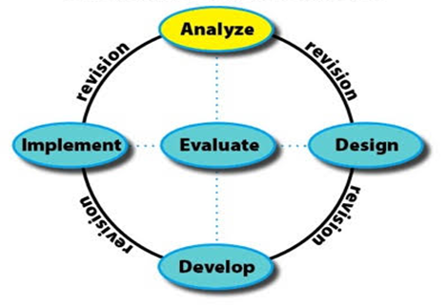

Figure 1. Application steps for the ADDIE development method, Branch (2009: 2)

The research site was conducted at MAN 2 Yogyakarta involving 72 students (28 trials 1 and 44 trials 2). Sampling-based on high, medium and low ranking categories, in the sampling using random sampling techniques. During the two stages of the trial students who become respondents differ.
Data analysis was performed using qualitative data analysis techniques and quantitative data (Widoyoko, 2012). Quantitative data were obtained from a questionnaire that was converted to qualitative data with a Likert scale of 5 to determine the feasibility of the product being developed, the steps are as follows:
- Change a quantitative assessment to be qualitative with the following conditions:
Table 1. Guidelines for Converting Quantitative Data to Qualitative Data
Classification | Scale
Very Good (VG) | 5
Good (G) | 4
Enough (E) | 3
Less (L) | 2
Very Less (VL) | 1
Source: (Widoyoko, 2009: 238)
- Calculate the average score of each indicator by the formula:
$\overline{X}$ = $\frac{\sum{x}}{N}$
Note:
No | Interval Scores | Value | Category | Range
1. | Very Good | A | X > $\overline{X}$ + 1,80 Sbi | X > 4,20
2. | Good | B | $\overline{X}$ + 0,60 Sbi < X $\underline{<}$ + 0,60 Sbi | 3,40 < X $\underline{<}$ 4,20
3. | Enough | C | $\overline{X}$ – 0,60 Sbi < X $\underline{<}$ $\overline{X}$ + 0,60 Sbi | 2,60 < X $\underline{<}$ 3,40
4. | Less | D | $\overline{X}$ – 1,80 Sbi < X $\underline{<}$ - 0,60 Sbi | 1,80 < X $\underline{<}$ 2,60
5. | Very Less | E | X $\underline{<}$ $\overline{X}$ – 1,80 Sbi | X $\underline{<}$ 1,80
$\overline{X}$ = Average score
$\sum{x}$ = Total score
$N$ = Number of test subjects
Source: (Sukardjo, 2005: 53)
- Qualitatively interpret the average score of each aspect.

Table 2. Score Convention Guidelines

Note:
X = Actual Score (score obtained)
$\overline{X}$ = (Ideal Average)
= $\frac{1}{2}$$1/2$ (Maximum Score + Minimum Score)
= $\frac{1}{2}$$1/2$ (5+1) = 3
Sbi = (Ideal Standard Deviation)
= $\frac{1}{6}$ $1/6$ (Maximum Score + Minimum Score)
= $\frac{1}{6}$ $1/6$ (5-1) = 0,67

Source: (Sukardjo, 2005: 53)
RESULT AND DISCUSSION
Based on research conducted, the product of this development is in the form of history learning modules based on Islamic values ​​of KH. Hasyim Asy'ari 1945 jihad resolution material for class XI. The process carried out by the ADDIE development model (analyze, design, development, implement and evaluate) developed by Branch (2009), namely by stages: 1) Analysis; 2) Design; 3) Development; 4) Implementation; 5) Evaluation. The steps are as follows.
- Analysis Stage
In the analysis stage, the researchers conducted a needs analysis that is the analysis of field studies and analysis of literature studies. Analysis of the field study was carried out by conducting unstructured observations and interviews with the teacher. At this stage of the analysis, the researcher looks for historical material that can be linked to Islamic values. The material developed is additional material contained in basic competencies 3.10.
- Design Stage
This design stage researchers gather the information that can be used to support the development of history learning modules that are made. The data collected is adjusted to the 2013 curriculum and then to the competency standard of history lessons, then summarized in the form of a draft temporary module. Modules are developed systematically with the suitability found in the study of literature. The steps taken at this design stage are to submit an initial draft module. Submitting the initial draft of this module with several stages including 1) Analyzing KI and KD with the material in the module, 2) Analyzing learning objectives, 3) Analyzing learning materials, and 4) Analyzing learning evaluations.
- Development Stage
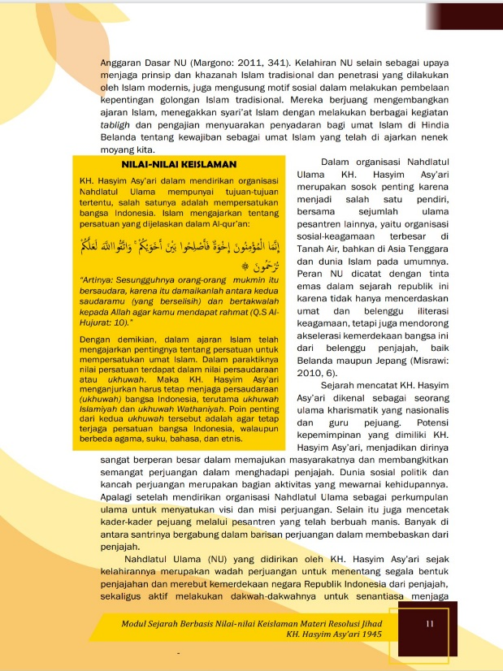
This stage is the realization of the previous stages so that at the development stage the researcher develops a module that has been designed. The researcher developed the material in the module with the help of Photoshop and Corel Draw applications.
Figure 2. Cover and module components
This development phase also refers to the 2013 curriculum that has been implemented in schools. In this stage, the researcher validates the initial product to material experts, media experts, and history teachers. Validation to the history teacher is carried out after passing the validation from the material experts and media experts after everything is done it will do a limited trial first before field trials. The results of the validation from the experts will be used as a revision/improvement of the initial product that has been developed. The product results that have been developed are as follows:
At the development stage, validation has been carried out on the experts, namely material experts, media experts, and teachers, the aim is to find out the feasibility of the module, as for the validation steps as follows.
- Material Expert Validation
The material validation includes aspects of the relevance of the material, learning design, and language in the history learning module based on Islamic values of the KH. Hasyim Ash'ari 1945 jihad resolution material, developed by researchers. The assessment data was obtained from the results of the questionnaire contents with a likert scale of 5 (1-5) that had been provided by researchers. The results of the material expert validation can be seen briefly based on the recapitulation of the material expert judgment presented in the following table.

Table 3. Results of Expert Material Validation
No | Assessment Aspects | Total Value | Average Value | Category
1. | Material Worthiness | 23 | 4.6 | Very Good
2. | Material Presentation Design | 69 | 4.9 | Very Good
3. | Linguistic | 22 | 4.4 | Very Good
Total |  | 114 | 4.75 | Very Good
Based on the table of results of the expert validation of the material above after being converted from quantitative data into qualitative data, the results obtained with an average score (X) of 4.75. The average score is included in the range X> 4.20, meaning that the history learning module product based on Islamic values developed based on the validation of material experts is included in the criteria of value A, which means the category of "Very Good". This means that the module is worth testing by material experts. The recapitulation of the results of the material expert validation can be presented in the following diagram.
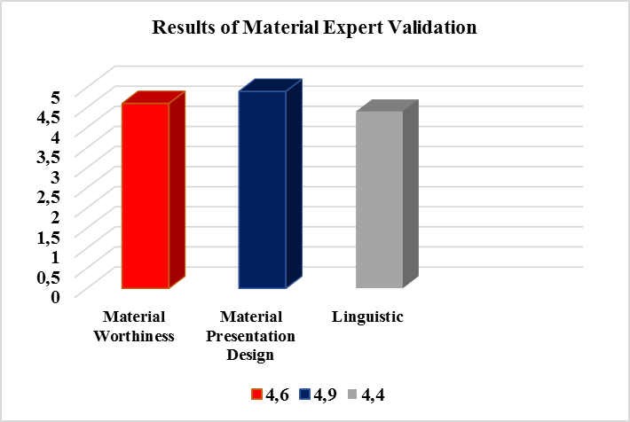

Figure 3. Validation Results Diagram Material Expert
- Media Expert Validation
Media expert validation is done after the product design stage is complete. Module media validation is carried out to determine the feasibility of the media listed in the history learning module before testing. The assessment was carried out by the validation of media experts related to the history learning module based on the Islamic values of the KH. Hasyim Asy'ari 1945Jihad resolution material includes the module graphics and module content design that has been developed by researchers. The history learning module media expert at this stage fills in the questionnaire prepared by the researcher with a choice of a Likert scale of 5 (1-5). Recapitulation of the results of the validation of media experts can be seen described in the following table.
Table 4. Results of Media Expert Validation
No | Assessment Aspects | Total Value | Average Value | Category
1. | Graphical | 22 | 4.4 | Very Good
2. | Module Content Design | 41 | 4.5 | Very Good
Total |  | 63 | 4.55 | Very Good
Based on the table of results of the validation of media experts it is known that the average score (X) is in the range X> 4.20. Obtaining the results of the media expert validation of Islamic learning module products based on Islamic values with an average value of 4.55 included in the criteria for the value of A "Very Good". This means that the history learning module products by media experts are declared worthy to be tested according to the advice and input gave by media experts. The recapitulation of the results of the validation of media experts is presented in a bar chart, can be seen in the following figure.

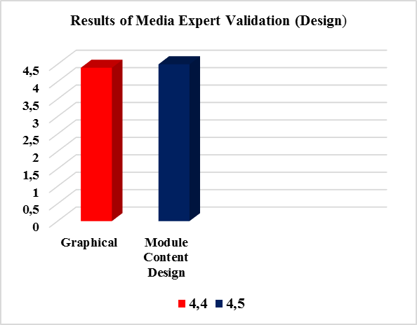

Figure 4. Validation Results Diagram Media Expert
- Teacher Validation
The history learning module product is based on Islamic values of KH. Hasyim Asy'ari 1945 jihad resolution material. before being tried out to students was first validated by the history teacher. The results of teacher validation can be seen from the following table.
Table 5. Results of Teacher Validation
No | Assessment Aspects | Total Value | Average Value | Category
1. | Presentation of Material | 16 | 4.0 | Good
2. | Module Content Design | 35 | 4.3 | Very Good
3. | Linguistic | 9 | 4.5 | Very Good
Total |  | 60 | 4.28 | Very Good

Based on the validation conducted by researchers of history subjects, the results obtained with an average score of (X) 4.28 in the range X> 4.20 means that the results of the score validation from the history teacher included in category A "Very Good", so that the modules that have been developed are worth testing out to students. Recapitulation of the results of validation by the teacher can be seen in the following diagram.

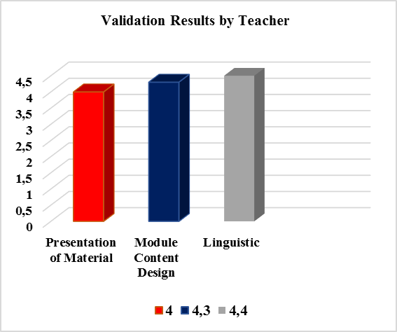

Figure 5. Validation Results Diagram of Teacher
- Implementation Stage
During the implementation stage, a trial is conducted, where the trial is carried out twice, considering that before a large-scale trial it is necessary to try a limited trial involving 28 students, to get an assessment from several students. While trial 2 (field) was conducted in class XI MAN 2 Yogyakarta in the IPS and PK programs involving 44 students.
Trial 1 or limited trials are conducted after obtaining validation from experts. The first trial involved 28 students of class XI IPA 3, the aim being to find out the initial response of students in responding to the modules that had been developed. The results of trial 1 can be seen in the following table.
Table 6. Students' Trial Responses 1
No | Assessment Aspects | Total Value | Average Value | Category
1. | Presentation of Material | 462 | 4.1 | Good
2. | Module Content Design | 758 | 4.5 | Very Good
3. | Linguistic | 276 | 4.9 | Very Good
Total |  | 1496 | 4.45 | Very Good
The results of responses from students to the modules that have been implemented in the learning process are converted from quantitative data into qualitative data, the results are known with an average score (X) of 4.45. This means that the score is included in the range of scores X> 4.20 which means that the module developed has an A with the category "Very Good". Thus, the module that has been tested in the first phase gets a very positive response, it means that the module is feasible to use.
In the trial stage 2 (field) students will assess the feasibility of the product that has been developed by researchers to be implemented. The results of trial 2 or field trials have become the final stage of the application of the development of the history learning module based on Islamic values. The responses of students in trial phase 2 can be seen in the following table.
Table 7. Students' Trial Responses 2
No | Assessment Aspects | Total Value | Average Value | Category
1. | Presentation of Material | 787 | 4,4 | Very Good
2. | Module Content Design | 1224 | 4,6 | Very Good
3. | Linguistic | 424 | 4,8 | Very Good
Total |  | 2435 | 4,61 | Very Good
Based on table 7, explaining that the results of the responses of students in the trial phase 2 (field) have obtained an average score of 4.61, which means that a score (X)> 4.20, which means included in the category of "Very Good". Then the modules that have been developed based on the response of trial 1 and trial 2, get responses from students who are very positive, so the modules developed are feasible to use. The recapitulation of the module implementation results towards students can be seen in the following diagram figure.

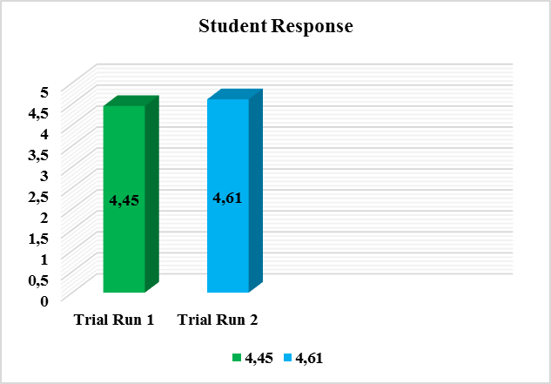

Figure 6. Student Response
Thus based on trials 1 and 2 show that the modules that have been developed are feasible to be used as a tool or media in learning history.
- Evaluation Stage
Overall evaluation stage researchers evaluated each stage to determine the progress and goodness of the product being developed. So this evaluation phase only evaluates the suggestions, comments, each stage, both from experts (material experts, media experts, history teachers, and students). Everything has been considered by researchers to be used as an evaluation material for products that have been developed for the good and progress of the module.
Based on previous research, several studies have been developed that develop teaching materials in the form of modules, some of which develop modules based on Islamic values of historical movements (Kuswono & Khaeroni, 2017) and develop teaching materials based on Islamic values in the sciences (Susilowati, 2017; Subarkah, et al., 2018; Syafitri & Darmana, 2018). Based on previous research, the renewal of this study lies in the history learning module based on Islamic values of the KH Jihad Resolution material. Hasyim Ash'ari 1945, which contains information about Islam as well as Al-Qur'an verses related to historical material so that it can broaden students' knowledge.
History learning module based on Islamic values of KH Jihad Resolution material. Hasyim Asy'ari 1945 was appropriate to be used in the learning process. In this case, the development of history learning modules needs to be continued because it will add variety and development as a source of history learning. As research conducted by (Maslahah & Rofiah, 2019; Mujiati, 2017; Trisnawati, 2015) who have developed historical teaching materials with different variations for the development and progress of history. Therefore, the development and innovations in history are needed to facilitate students in understanding history.

CONCLUSION
Based on the results of development research, it can be concluded that the history learning module is based on Islamic values ​​of KH Jihad Resolution material. Hasyim Asy’ari for class XI is appropriate. Based on the results of the feasibility test by material experts, media experts, teachers, and students. The results obtained from material experts with an average score of 4.75, 4.55 media experts, 4.28 teachers, trial 1 (limited) 4.45 and trial 2 (field) 4.61. Overall included in the category of very feasible (A) and have received positive responses from students. This means that the module is declared eligible to be used as a medium or medium in learning history.
The implication of history learning modules based on Islamic values ​​can contribute to developing students' knowledge in terms of Islam and can be applied in everyday life. This module can also be used in learning activities and can broaden students' knowledge. The results showed a history learning module based on Islamic values ​​declared feasible, practical and effective. Also, researchers hope that the innovations in learning history can change the negative views of students towards history that only studies the past, becomes interested and interesting in learning history.
REFERENCES
Abdulahmeed, M. I. (2013). The Efectiveness af a Proposed Program Based on Integrated Educational Modules To Develop Sex Seducation For Kindergarten Children. European Scientific Journal, 9(28), 283–297. Retrieved from https://eujournal.org/index.php/esj/article/view/1898/1840
Aman. (2011). Evaluasi Pembelajaran Sejarah. Yogyakarta: Ombak.
Aman. (2019). History Teachers’ Competence In Implementing Authentic Assessment: A case study in a state senior high school in Yogyakarta. International Journal of Learning, Teaching and Educational Research, 18(10), 68–89. https://doi.org/10.26803/ijlter.18.10.5
Bachtiar, T. A. (2015). Muatan Nilai Islam dalam Penulisan dan Pengajaran Sejarah. Jurnal Pendidikan Agama Islam, 12(2), 201–219. https://doi.org/https://doi.org/10.14421/jpai.2015.122-06
Berkowitz, M. W., & Bier, M. C. (2004). Research Based Character Education. Annals of the American Academy of Political and Social Science. https://doi.org/10.1177/0002716203260082
Bizawie, Z. M. (2014). Laskar ulama -Santri & Resolusi Jihad Garda Depan Menegakkan Indonesia (1945-1949). Jakarta: Pustaka Compas.
Branch, R. M. (2010). Instructional design: The ADDIE approach. New York: Springer. https://doi.org/10.1007/978-0-387-09506-6
Chen, H., Wang, S., Gao, H., Feng, X., Yan, C., & Tang, A. (2019). Analysis and optimization of module layout for multi-stack vanadium flow battery module. Journal of Power Sources, 427, 154–164. https://doi.org/10.1016/j.jpowsour.2019.04.054
Daryanto. (2013). Menyusun Modul (Bahan Ajar Untuk Persiapan Guru dalam Mengajar). Yogyakarta: Gava Media.
Dewi, T. M. (2017). Pengembangan Modul Pencemaran Lingkungan Berbasis Islam-Sains untuk Siswa Madrasah Aliyah/MA. Jurnal Pendidikan Biologi, 6(2), 274–279. https://doi.org/10.24114/jpb.v6i2.6545
Dwiningrum, S. I. A. (2013). Nation’s character education based on the social capital theory. Asian Social Science, 9(12), 144–155. https://doi.org/10.5539/ass.v9n12p144
Dyah Kumalasari. (2018). Agama dan Budaya sebagai Basis Pendidikan Karakter di Sekolah. Yogyakarta: Suluh Media.
El-Guyanie, G. (2010). Resolusi Jihad Paling Syar’i. Yogyakarta: LKiS.
Enke, J., Kraft, K., & Metternich, J. (2015). Competency-oriented design of learning modules. Procedia CIRP. https://doi.org/10.1016/j.procir.2015.02.211
Fadli, M. Rijal dan Hidayat, B. (2018). KH. Hasyim Asy’ari dan Resolusi Jihad dalam Usaha Mempertahankan Kemerdekaan Indonesia Tahun 1945. Lampung: Laduny Alifatama.
Fadli, M. R. F. dan Miftahuddin. (2019). Dari Pesantren Untuk Negeri: Kiprah Kebangsaan KH. Hasyim Asy’ari. Jurnal Islam Nusantara, 3(2), 1–27. https://doi.org/10.33852 / jurnalin.v3i2.138
Hamid, Abd Rahman dan Madjid, M. S. (2011). Pengantar Ilmu Sejarah. Yogyakarta: Ombak.
Hasan, S. H. (2012). Pendidikan Sejarah Indonesia: Isu dalam Ide dan Pembelajaran. Bandung: Penerbit Rizky.
Ikhwan, A. (2014). Integrasi Pendidikan Islam (Nilai-Nilai Islami dalam Pembelajaran). Ta’allum: Jurnal Pendidikan Islam, 2(2), 179–194. https://doi.org/10.21274/taalum.2014.2.2.179-194
Ismail. (2016). Character Education Based on Religious Values: an Islamic Perspective. Ta’dib, 21(1), 41–58. https://doi.org/10.19109/td.v21i1.744
Kuswono, K. (2013). Character Education Muhammadiyah Pattern (Case Study SMA Muhammadiyah 1 and MA Muallimin Yogyakarta). GUIDENA: Jurnal Ilmu Pendidikan, Psikologi, Bimbingan dan Konseling, 3(1), 42–49. https://doi.org/10.24127/gdn.v3i1.374
Kuswono, K., & Khaeroni, C. (2017). Pengembangan Modul Sejarah Pergerakan Indonesia Terintegrasi Nilai Karakter Religius. HISTORIA, 5(1), 31–44. https://doi.org/10.24127/hj.v5i1.730
Lee, W. W., & Owens, D. L. (2012). Multimedia-Based Instructional Design. https://doi.org/10.1007/s13398-014-0173-7.2
Lickona, T. (1996). Eleven principles of effective character education. Journal of Moral Education. https://doi.org/10.1080/0305724960250110
Maslahah, W., & Rofiah, L. (2019). Pengembangan Bahan Ajar (Modul) Sejarah Indonesia Berbasis Candi-Candi Di Blitar Untuk Meningkatkan Kesadaran Sejarah. Agastya: Jurnal Sejarah Dan Pembelajarannya, 9(1), 32–44. https://doi.org/10.25273/ajsp.v9i1.3418
Mujiati, N. (2017). Modul Sejarah Perlawanan Masyarakat Lampung Abad Ke-19 Berbasis Problem Based Learning (PBL). Sejarah dan Budaya : Jurnal Sejarah, Budaya, dan Pengajarannya, 11(1), 37–46. https://doi.org/10.17977/um020v11i12017p037
Munadi dan Yudhi. (2013). Media Pembelajaran: Sebuah Pendekatan Baru. Jakarta: Referensi.
Olson, D. R. (2009). The history of writing. In The SAGE Handbook of Writing Development. https://doi.org/10.4135/9780857021069.n2
Prastowo, A. (2015). Panduan Kreatif Membuat Bahan Ajar Inovatif. https://doi.org/10.1017/CBO9781107415324.004
Pratiwi, D. D. (2019). Pengembangan Bahan Ajar Aljabar Linier Berbasis Nilai-nilai Keislaman dengan Pendekatan Saintifik. Desimal: Jurnal Matematika, 2(2), 156–165. https://doi.org/10.24042/djm.v2i2.4200
Rahmawati, A., & Rizki, S. (2017). Pengembangan Bahan Ajar Matematika Berbasis Nilai-Nilai Islam Pada Materi Aritmatika Sosial. AKSIOMA: Jurnal Program Studi Pendidikan Matematika, 6(1), 81–89. https://doi.org/10.24127/ajpm.v6i1.860
Schott, F., & Seel, N. M. (2015). Instructional Design. In International Encyclopedia of the Social & Behavioral Sciences: Second Edition. https://doi.org/10.1016/B978-0-08-097086-8.92032-4
Subarkah, C. Z., Qolbi, A. N., Irwansyah, F. S., Darmalaksana, W., & Mahmud, M. (2018). Developing E-Module Based on Islamic Values. 190–194. https://doi.org/10.5220/0007095201900194
Sukardjo. (2005). Evaluasi Pembelajaran Sejarah Semester 2. Yogyakarta: Program Pascasarjana Universitas Negeri Yogyakarta.
Supardi. (2006). Pendidikan Sejarah Lokal Dalam Konteks Multikulturalisme. Cakrawala Pendidikan, 25(1), 117–137. https://doi.org/https://doi.org/10.21831/cp.v0i1.395
Susilowati, S. (2017). Pengembangan Bahan Ajar IPA Terintegrasi Nilai Islam untuk Meningkatkan Sikap dan Prestasi Belajar IPA Siswa. Jurnal Inovasi Pendidikan IPA, 3(1), 78–88. https://doi.org/10.21831/jipi.v3i1.13677
Syafitri, A., & Darmana, A. (2018). Development of chemistry module integrated with islamic values in thermochemistry and reaction rate for senior high school student. Jurnal Pendidikan Kimia, 10(3), 418–424. https://doi.org/10.24114/jpkim.v10i3.12720
Trisnawati, D. (2015). Pengembangan Modul Pembelajaran Sejarah Berbasis Pendidikan Karakter Dalam Meningkatkan Nasionalisme Di Sekolah Pendidikan Layanan Khusus Yayasan Girlan Nusantara. ISTORIA: Jurnal Pendidikan dan Ilmu Sejarah, 11(1), 42–53. https://doi.org/10.21831/istoria.v11i1.5762
Wasino dan Hartatik Endah Sri. (2018). Metode Penelitian Sejarah: dari Riset Hingga Penulisan. Yogyakarta: Magnum Pustaka Utama.
Widoyoko, E. P. (2009). Evaluasi Program Pembelajaran. Yogyakarta: Pustaka Pelajar.
Yilmaz, K. (2008). A Vision of History Teaching and Learning: Thoughts on History Education in Secondary Schools. The High School Journal, 92(2), 37–46. https://doi.org/10.1353/hsj.0.0017
Yuniati, S., & Sari, A. (2018). Pengembangan Modul Matematika Terintegrasi Nilai-Nilai Keislaman melalui Pendekatan Realistic Mathematics Education (RME) di Propinsi Riau. Jurnal Analisa, 4(1), 1–9. https://doi.org/10.15575/ja.v4i1.1588

